**Chapter 10 Creating Tables With Constraints**

**Where Is This Chapter Covered In The Course?**

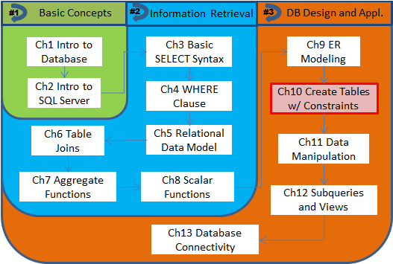

**Chapter Outlines**

Using the SQL Server Management Studio

* Create a database
* Create a table

Creating a Table Using SQL

* Data types used in SQL Server
* Type of constraints and related keywords

Specifying Constraints

* Specifying constraints during table creation
* Modifying table to add constraints

Strategies of Creating Tables in an Orderly Manner

Enforcing Valid Value Range

* Using the CHECK constraint
* CHECK vs. FK constraints

**Creating a Table Using SQL**

As mentioned earlier, statements for creating (and modifying) tables belong to a set of database language that is referred to as DDL (short for data definition language). The basic structure of the CREATE TABLE statement can be illustrated as

CREATE TABLE table_name (

column_name data_type [constraint-specs-at-column-level],

[column definition], //repeated as necessary

[constraint-specs-at-table-level]);

**Data types used in SQL Server.** Data types used in SQL Server [1]can be grouped roughly into four categories, as shown in the table below. Only the types that we will use in this course are explained.

Table 10.1 - Data Types Used in SQL Server

|  |  |  |
| --- | --- | --- |
| **Categories** | **Data Types** | **Description** |
| Numeric | int  decimal(p[,s]) and  numeric(p[, s]) | For integers.  For fixed precision (p) and scale (s) numbers, where p (between 1 and 38) is the total number of digits, and s is the number of digits after the decimal point. |
| Strings | char[(n)]  varchar(n)  nchar or nvarchar | For fixed length non-Unicode string data. The length is n (with a maximum of 8000) if specified or 1 if not.  For variable-length non-Unicode string data.  For fixed- or variable-length Unicode string data. |
| Temporal (date/time) | datetime | Defines a date that is combined with a time of day with fractional seconds that is based on a 24-hour clock. |
| Other | binary[(n)] or varbinary[(n)] | For fixed- or variable-length binary data with (up to) n bytes, where n is between 1 and 8000. |

**Types of constraints and related keywords.** Specifying constraints is the standard way to request the DBMS (such as SQL Server) to enforce business rules. We will discuss the following types.

|  |  |  |
| --- | --- | --- |
| **Keyword** | **Purpose** | **Description** |
| PRIMARY KEY | To specify the primary key in a table. | This keyword means UNIQUE and NOT NULL. In SQL Server, an index will be created for a PK. |
| UNIQUE | To specify a (candidate) key in a table. | Defines a (non-PK) candidate key. In SQL Server, an index will be created for a UNIQUE key. May not be used together with PRIMARY KEY. |
| FOREIGN KEY | To specify a foreign key that references to a key in another table. | Defines a FK. A REFERENCES phrase is always needed to specify the parent table. By default, a FK is linked to the PK in the parent table. But it may be linked to any UNIQUE key when it is specified with the syntax REFERENCES table_name(u_k[, u_k2,…]). |
| NOT NULL | To specify a ***required*** column with no NULL value allowed. | May only be specified at column-level. |
| CHECK | To specify valid range for a column. | Any valid predicate acceptable in the WHERE clause may be used in CHECK(predicate). |

**Specifying Constraints**

**Specifying constraints during table creation.** Let us see how to specify PK and candidate key when creating the Department table by modifying query Q10.1.

/* Q10.2 */

CREATE TABLE Department (

DeptID int **PRIMARY KEY**,

DeptName varchar(50) **UNIQUE NOT NULL**,

FaxNo char(10));

To specify a foreign key, we need to use the syntax

FOREIGN KEY REFERENCES table_name(key_name)

When referencing a PK, simply use

FOREIGN KEY REFERENCES table_name

**Modifying table to add constraints.** Sometimes, a constraint may not be specified during table creation. For instance, the FK ChairID in the Department table may not be specified since we created the Department table before the Professor table is created. We then need to add the constraint after table creation, either using Table Designer or using SQL. We will show how to ALTER TABLE to add this constraint with query Q10.4.

/* Q10.4 */

**ALTER TABLE** Department

**ADD ChairID int** **FOREIGN KEY REFERENCES Professor**;

**Strategies of Creating Tables in an Orderly Manner**

* **Parent-table before child-table(s)**
* **Specification during vs. after table creation**
* **Row-level vs. table-level specification**

/* Q10.7 */

ALTER TABLE Section

**ADD FOREIGN KEY(CourseID) REFERENCES Course**;

**Enforcing Valid Value Range**

* **Using the CHECK constraint**
* **CHECK vs. FK constraints**

1. For more details, check Microsoft documents online at <https://docs.microsoft.com/en-us/sql/t-sql/data-types/data-types-transact-sql>.